9. Palindrome Number

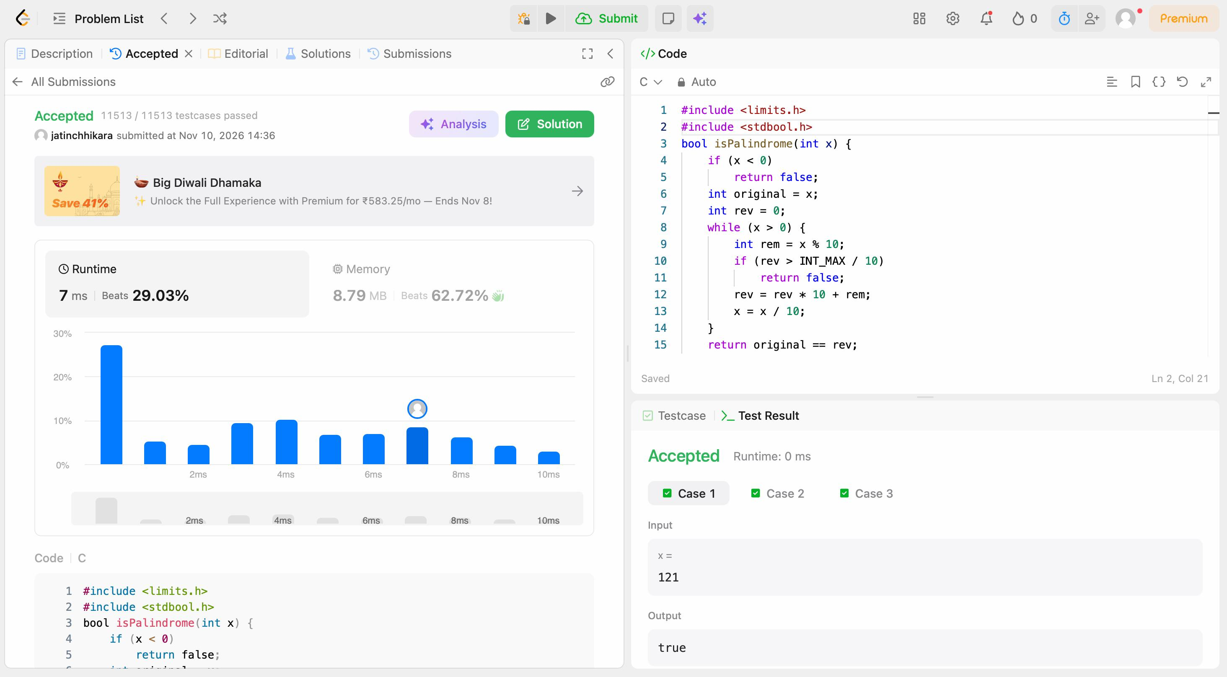
Code:
#include <limits.h>
#include <stdbool.h>
bool isPalindrome(int x) {
if (x < 0)
return false;
int original = x;
int rev = 0;
while (x > 0) {
int rem = x % 10;
if (rev > INT_MAX / 10)
return false;
rev = rev * 10 + rem;
x = x / 10;
}
return original == rev;
}

